**PREDICTIVE ANALYTICS USING SAS  
Group 10**

**Project Report**

**Formulating marketing strategies for diaper industry**



**By:**

1. Ashish Sharma
2. Atharva Bendre
3. Manish Shukla
4. Mudit Sharma
5. Tanmay Jain

Recommendations

All marketing campaigns should pick up a target segment first, then create promotional material that will resonate with that audience, and then put the pedal to the metal.

### Target Customer

* Customers in age bracket of 4 should be the primary target for marketing and advertisement as they contribute highest to the sales.
* Educated customers tend to purchase more diapers with customers base distributed among all the brands. Company can run an advertisement explaining safety and health issues taken care of while designing the product to attract educated and concerned customers.

### Market Decisions

* Display of the product affects the sales of the product, hence in order to maintain the dominance in the market, company should ensure the display of product in stores is maintained.
* Reducing price would not entice the customer to switch, hence the company should focus on other aspects the product to attract customers that are not loyal
* New member drawings - Win $50 in store credit, just make a purchase

### At risk customers

* Reactivation campaigns
* ‘We miss you’ offer - Save 10% on your purchase.

**Break Down of Total Dollars by Brand and Age Group Male & Female**

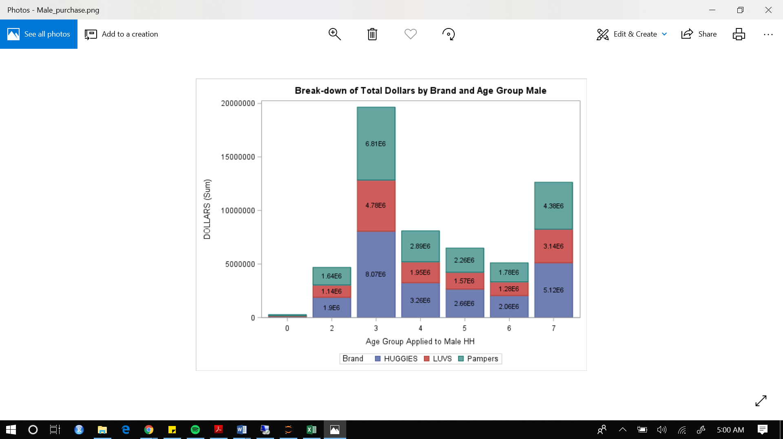 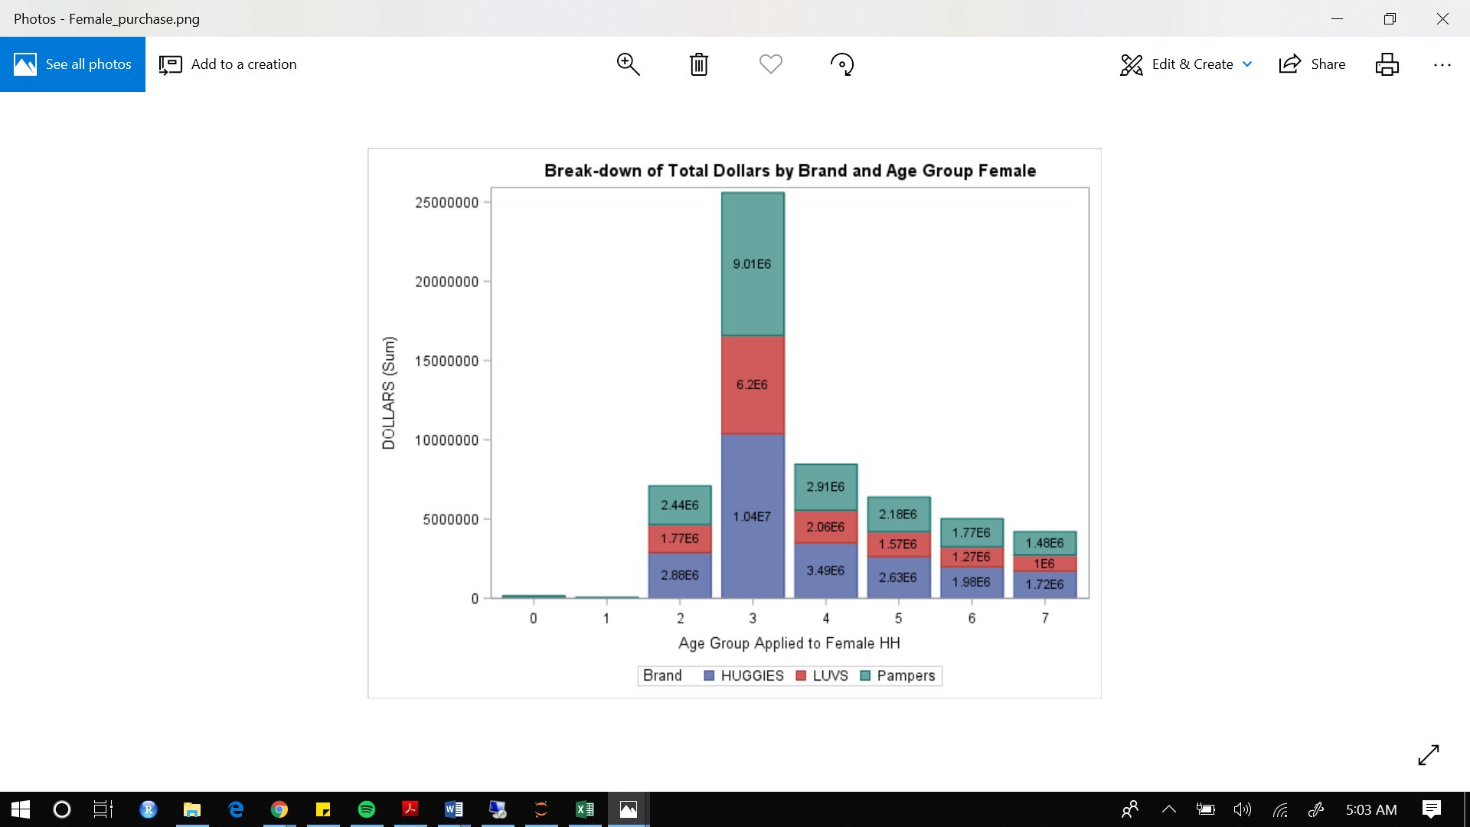

In general, households with males in the age group of 35-44 (group 3) spent the most on diapers as compared to other groups. The purchase of diapers for the following age groups reduces with the increase in age but it increases significantly for age group 65+ with it being the second highest.

The brand with the highest dollars sales in this group is HUGGIES. This pattern remains true for households with other groups as well. Brand with second highest dollar sales is PAMPERS and LUV stands at the third. Like the distribution of Male, in general, households with females in the age group of 35-44 (group 3) also spent the most on diapers as compared to other groups. With HUGGIES being the highest seller for them.

Also, it can be implied from the trends that for females, as the age increases, woman of the household tend to make less purchase of diapers which can be expected.

**Break Down of Total Dollars by Brand and Age Group Male & Female**

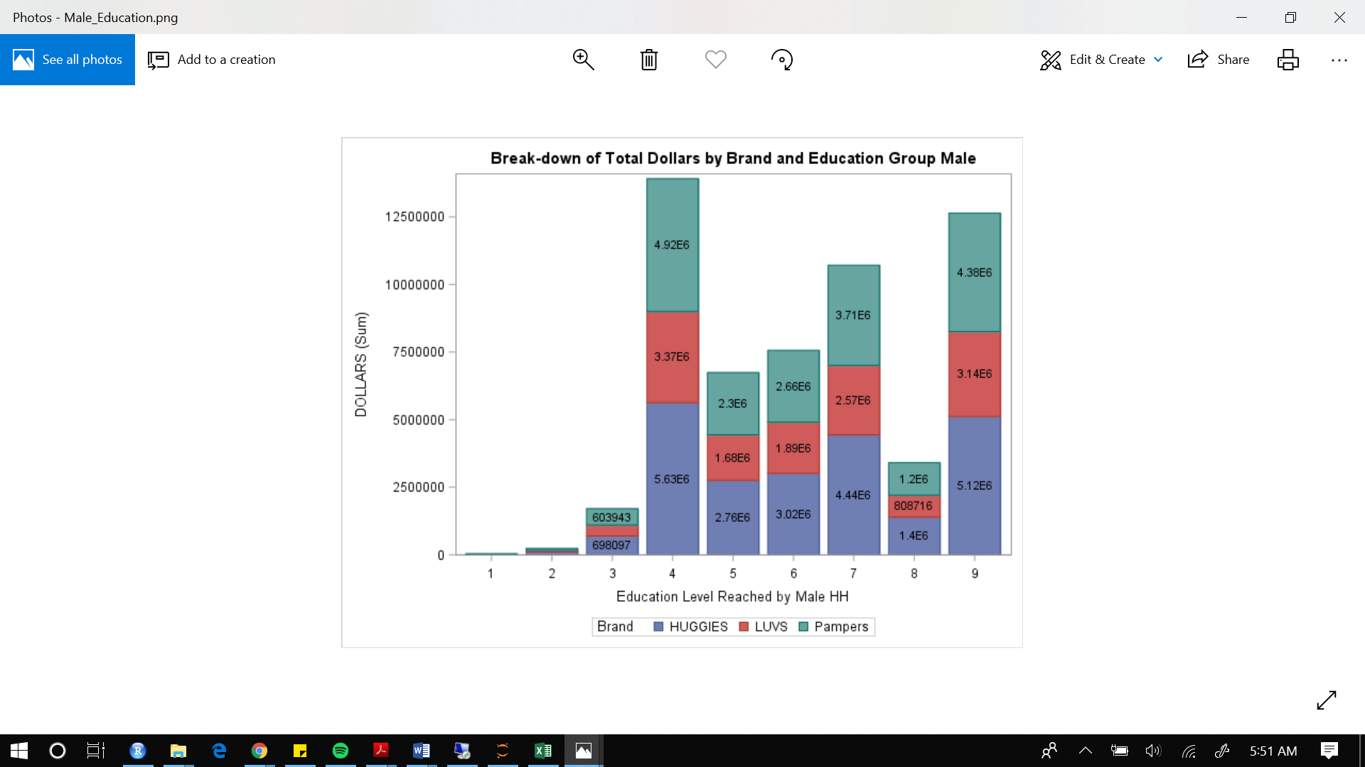 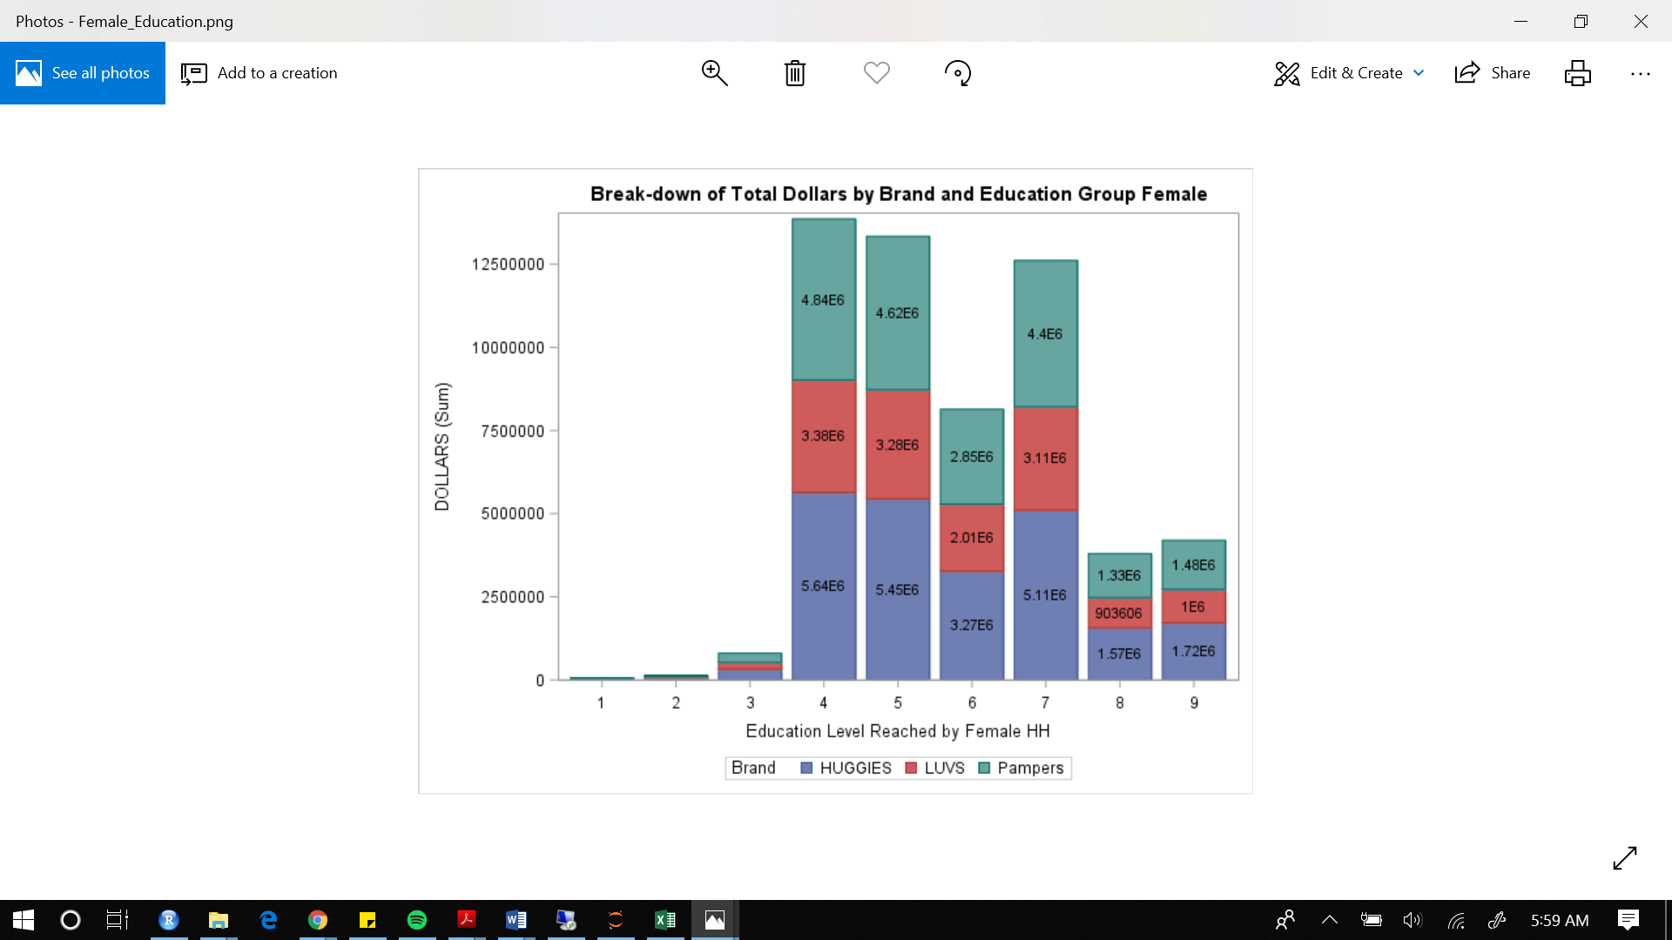

For households with males as buyers, we can see that there is an irregular trend which could be based on distribution of data. Males with education level (4) contribute most to the sales of diapers while the males with the education level of 9 stand at the second highest position in purchasing diapers.

Like the distribution of Male, in general, households with females having education level 4 also spent the most on diapers as compared to other groups with HUGGIES being highest seller for them. Also, it can be implied from the trends that for females, as the age increases, woman of the household tend to make less purchase of diapers which can be expected.

# What is the effect of advertising and promotion on the market?

The next logical step after deciding on the scope of the analysis was to understand the diaper industry and the underlying trends. We wanted to analyze the effect of price, promotion, and advertisement. Following are the questions we wanted to answer:

1. Is the customer's price sensitive and to what extent?
2. How effective are promotions and advertisements in driving product sales?
3. What is the effect of a competitors marketing activities on the sales?
4. How do competitor’s price reduction, promotion, and advertisement affect sales?

## Analysis

To measure the price sensitiveness of customers and their behavior to change in promotion and advertisement, we developed a panel regression with unit sold as the dependent variable and unit price of Huggies, promotional and advertisement flags along with information about the competitor’s price, promotion, and advertisement as the independent variables.

Other interaction variables were removed because of high correlation

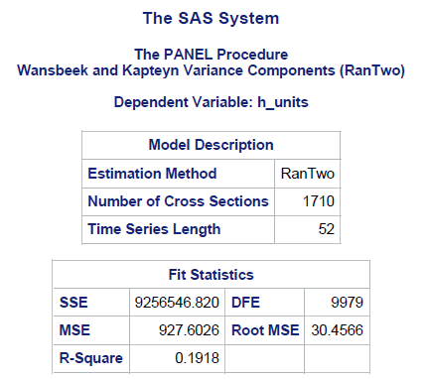 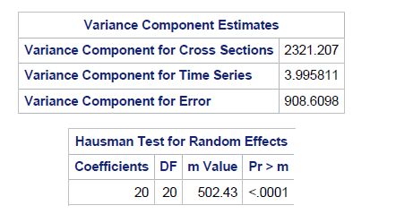

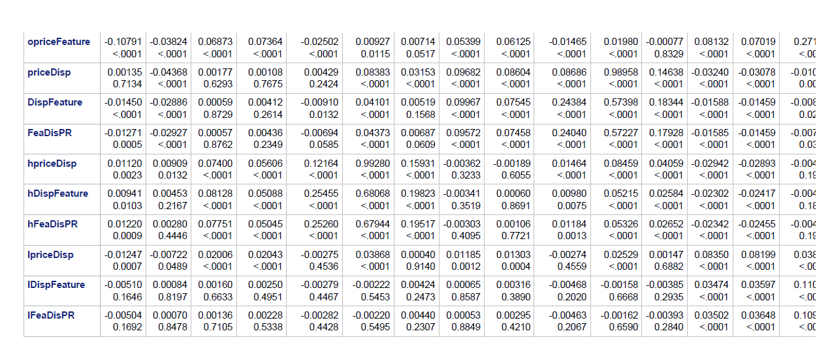

We used a weighted price, units, display, features and price reduction to aggregate the data at the brand level. Panel regression was selected to account for geographic level heterogeneity.

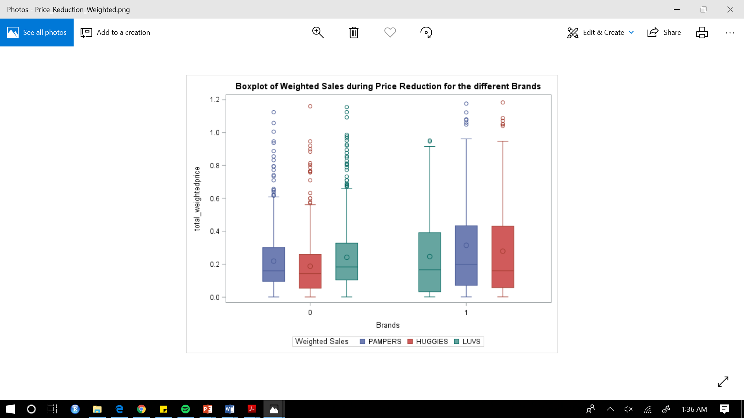 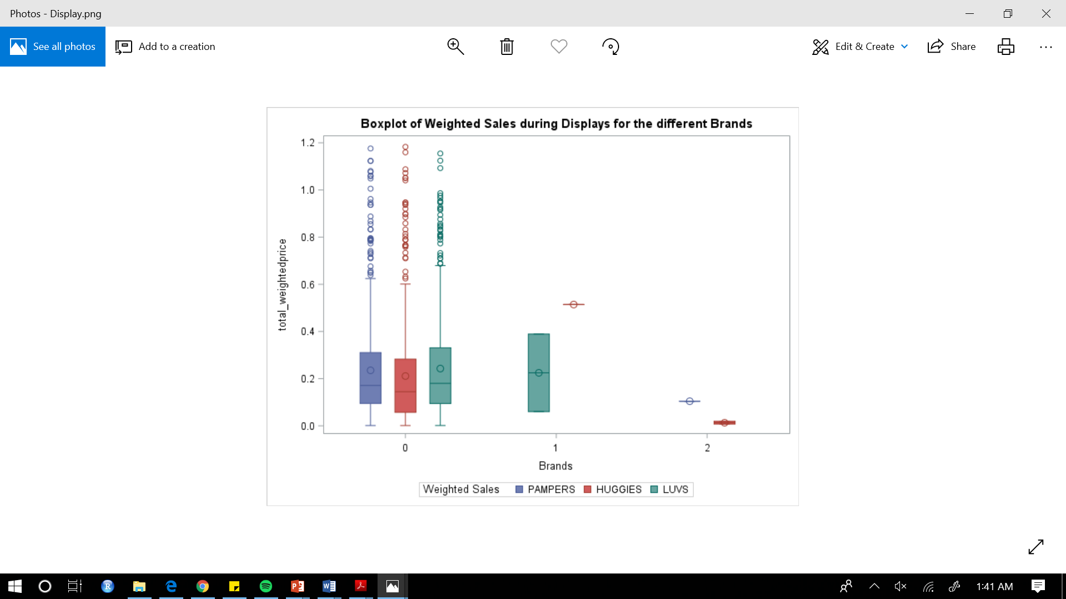

The effects of price reduction and displays were hidden because the dollars and units recorded were representative of the whole purchase trip and not specific to the brand or product bought. After aggregating it down to unit sales, the difference in sales generated becomes more readily apparent.

On a whole, displays regardless of size tend to be associated with a higher increase of sales as

compared to no displays. This relationship does not hold true for other modes of advertisement. Therefore, displays is a safer advertising option.

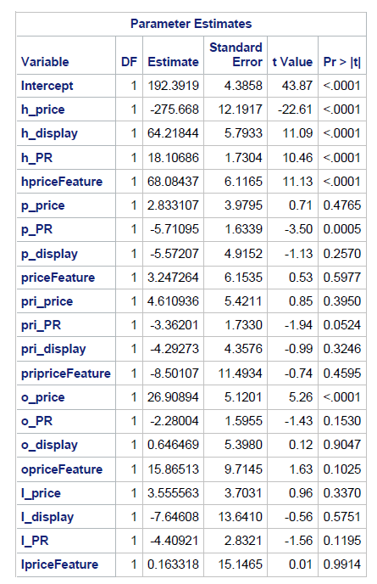

Based on the P values of the Hausman test we reject the null hypothesis in favor of the alternative hypothesis that the error terms are correlated and hence random panel regression was not selected.

Running fixed panel regression gave us the following result:

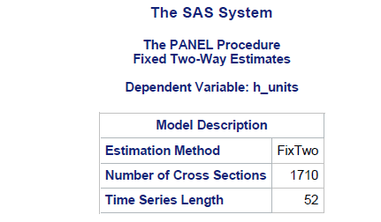 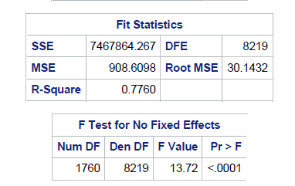

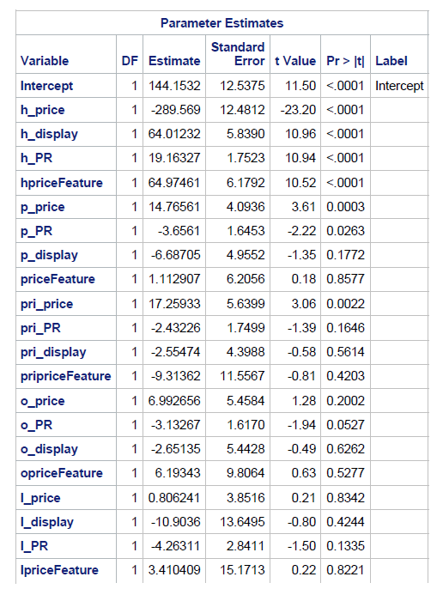

Based on the results of our analysis we conclude that the diaper market is highly price elastics and the display advertisements and price reduction have a positive impact on sales. Changes in competitor also affect sales of Huggies product but display advertisement have not significant effect on sales.

# Which segment of customers is driving sales for Huggies?

After arriving at the conclusion that the diaper market if sensitive to promotion, next to develop personalized marketing campaigns we first wanted to understand various customers behavior. Instead of reaching out to 100% of the audience, we need to identify and target only specific customer groups that will turn out to be most profitable for the business. We wanted answers to the following questions

* Who are my best customers?
* Which customers are on the verge of churning?
* Who has the potential to be converted into more profitable customers?
* Who are lost customers that you don’t need to pay much attention to?
* Which customers must you retain?
* Who are your loyal customers?
* Which group of customers is most likely to respond to your current campaign?

## Analysis

We considered a wide array of behavior metrics to segment the customer base. Some metrics were not due to high bias in the data and other were highly correlated

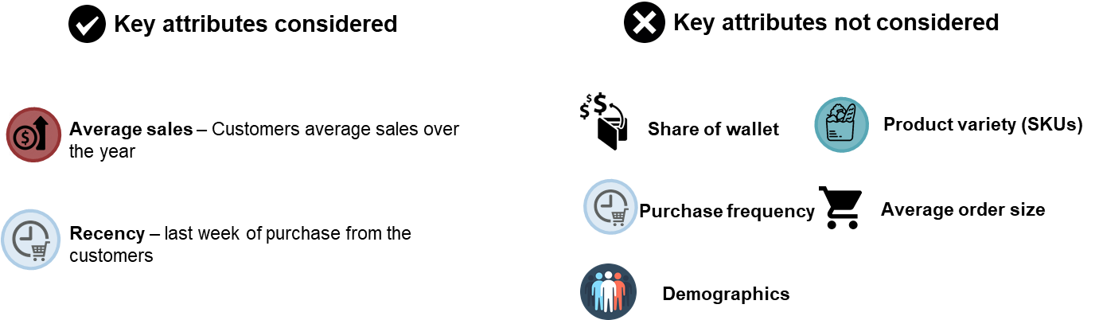

The customer was segmented based on the recency of purchase and the average monetary worth for Huggies. The overall customer population was divided into 5 quantiles and recency and a monetary score of 1-5 was given respectively. Scores for frequency and monetary were combined because of their high correlation.

## Results

The distribution of active customer base was as follows:

### Champions – 23.41%

Bought recently, buy often and spend the most

### Potential customers - 14%

Recent customers, but spent a good amount and bought more than once

### At risk customers – 20%

Spent big money and purchased often. But a long time ago. Need to bring them back!

### Lost customers – 42.49%

Lowest recency, frequency, and monetary scores